My csv files had 100000 rows to upload.

This was extremely slow with MYSQL's table upload wizard tool. It seemed like it would take a week to finish.

Instead, I used the inline functionality.

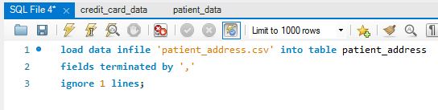

To do this I had to disable secure_file_priv from C:/ProgramData/MySQL/MySQL Server 8.0/my.ini

* Open the file in as an administrator in notepad
* Delete location from the file (creates NULL)

Then I moved the files I wanted to upload into the data folder in

* C:\ProgramData\MySQL\MySQL Server 8.0\Data\mock_patient_project

This was tricky since I didn’t give myself access to this folder

* I changed the security permissions but not sure what did the trick

I then just ran the SQL code and it worked in less than a minute.

I did have to have the table already set up. I did use the upload wizard tool for this.

I just stopped this as soon as it started so i have the table i wanted created and deleted any rows that had uploaded. to do this though I had to disable the safety in preferences in MySQL.